OCEAN GALLERY NEWSLETTER

Landscape, landscape, landscape!!
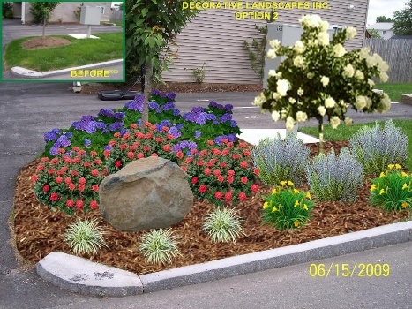

Two hurricanes back to back wore some of the landscaping out. Each association is handling the landscaping in different ways and with different budgets. Las Palmas which was heavily planted years ago received the least amount of damage on their roofs and landscaping and is working with a wonderful landscaping committee to address their needs.
Village Del Lago has been using Mark (their maintenance man) and the Mofrans to address the landscaping building by building.
Del Prado and the Vistas received bids for a professional landscape to be installed. The Vistas are done with the front side of the buildings and Del Prado’s project is scheduled to start December 1st. The Vista landscaping project for the rear of the buildings will be done over the late winter early spring months after the landscape curbing has been addressed.
The Property Owners Association roadway island project began just a couple of weeks ago and the new plantings were installed. The office has received lots of compliments.

Roofs
All four communities received damage from the hurricanes and had roofing replacement done this past summer. A total of 17 roofs were replaced and close to 100,000.00 in roofing repair bills were paid by the Vistas for roofing repair. The insurance companies finally paid the claims after a year of wrangling with experts. It was a shame that it took so much effort to convince the insurance company to do the right thing.
Tot Lot
The Board of Directors selected a Tot Lot Committee in the spring and the results of the committee’s work can be seen in the tot lot area in front of the clubhouse. We will be installing a sail shade soon to provide some shade to parents while watching their children play.
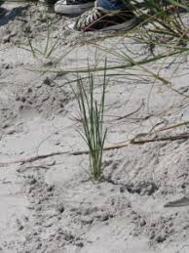
Volunteers
The community had a great turn out for the Sea Oats planting project. The group worked together and properly installed over 1000 plants in a few short hours. The weather held out and the group accomplished its task in short order after waiting over a year for plants and permitting. The community effort over the past 10 plus years has helped to secure and sustain a healthy dune system to protect the community from the rising sea water.
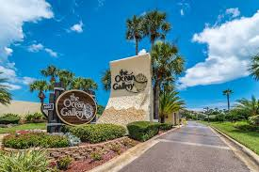
The Community at large
The association is currently looking at options to replace and update some of the equipment in the exercise room. The treadmills are at the end of their life cycle and some of the equipment is showing its age. A few of the pieces of equipment are over 20 years old. The community has replaced the tennis court lights with LED lights recently as the old fixtures and bulbs were failing. Take a walk to see the bright new look!
Over the winter months the crews will be repairing the concrete curbing in the rear of the Vista buildings and addressing the replenishment of the small flower bed rocks, plantings etc. The crews will also begin next week sealing the roofs up again for bats and washing the roofs in the Vistas. A lift will be used for these projects and you may have to tolerate a lift operating outside your patio for a few hours during this time. Sherri can provide you with data sheet for the chemicals being used. The product being used is plant friendly and is purchased through Walmart.com.
Rentals
We are finishing the year on a positive note with payments to owners again exceeding the prior year. We continue to advertise heavily as more and more rooms are being created in St. Augustine yearly and even some competition within the community as some owners are booking their condominiums at heavy discounts in an effort to fill every night. We recently completed a market survey of our local competition and the results will be discussed at the January rental board meeting. The comment cards received this year were very positive, the community received lots of praise for how beautiful things looked and are being taken care of and the friendliness of the staff.
We are now offering to the rental owners a virtual tour or 3-D walk through to replace the stock photographs on the web. It is optional and cost 185.00. Just Google Matterport for more details and contact the office if you are interested. We feel this may increase your bookings.
We are asked each year by several charities for a condominium to raffle at an auction. Limelight Theater, Counsel on Aging, Wounded Warriors, Thin Blue Line (police) and Police Unity Tour to name a few. If you wish to donate your condo for a Charity fund raiser, please let Anne Martinez in the rental office know and she can provide more details.

WE WISH ALL OF YOU A HAPPY HOLIDAY SEASON!!

